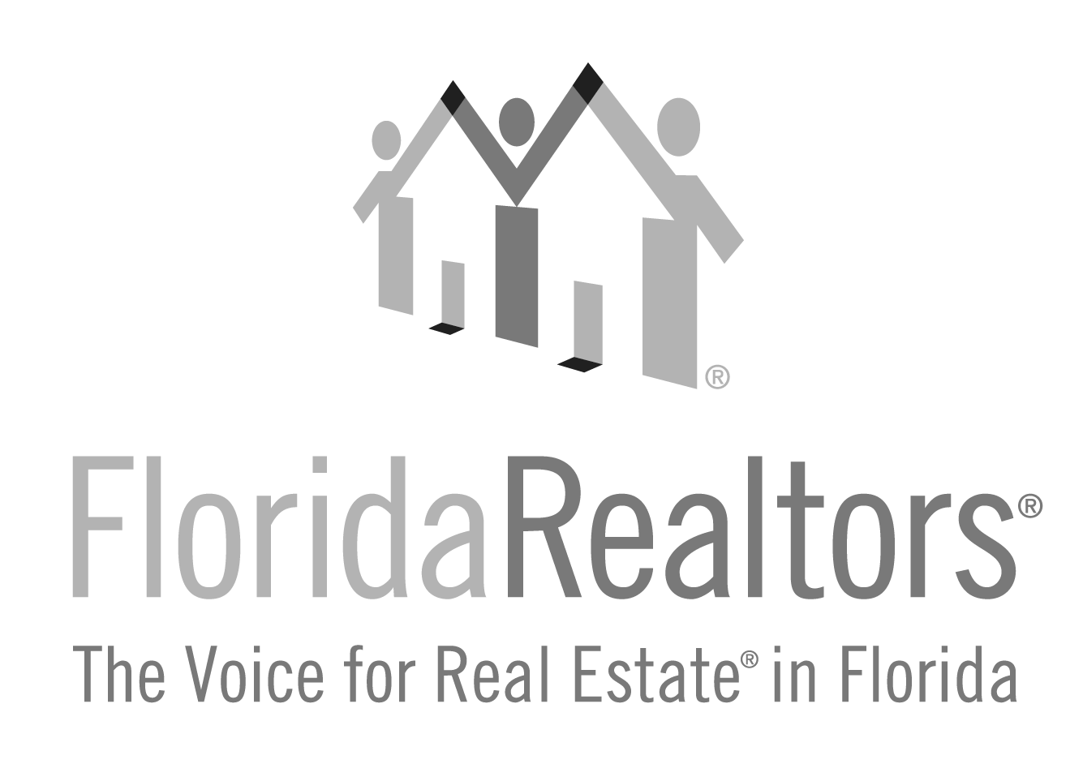

Realtor® Achievement Award
Honoring a Realtor® (broker of record, manager or officer of a company), other than a current or past Florida Realtors® president, based on their contributions to their local board/association, state association, national association and community.

2024 Entry Form

All applications must be typed with no less than 12-point type size and must be received at Florida Realtors® by Friday, July 5, 2024. One letter of recommendation from the board/association is welcome but not required. If you have any questions, please contact Gina Wittenhagen at (407) 438-1400, ext. 2343 or ginaw@floridarealtors.org

Full Name of Nominee:

Nominee’s position in the company (Please verify and check at least one):
Broker of Record Manager Officer

Nominee’s Board/Association Affiliation:

Nominee’s Company & Title:

Nominee’s Complete Address:

_______________________________________________________________________________________Local Board/Association President or Association Executive’s Signature
2024 Realtor Achievement Award Entry Form
Complete and return to:
Florida Realtors®
Attn: Gina Wittenhagen
7025 Augusta National Drive
Orlando, FL 32822-5017

Application must be received at Florida Realtors by Friday, July 5, 2024
”
“
To encourage individual activity that will identify and recognize Realtors as community leaders.

Page 2

Please briefly describe your nominee’s involvement in the community as well as local, state and national associations. (No additional pages will be accepted. Please use this form only at no less than 12-point type size.)

