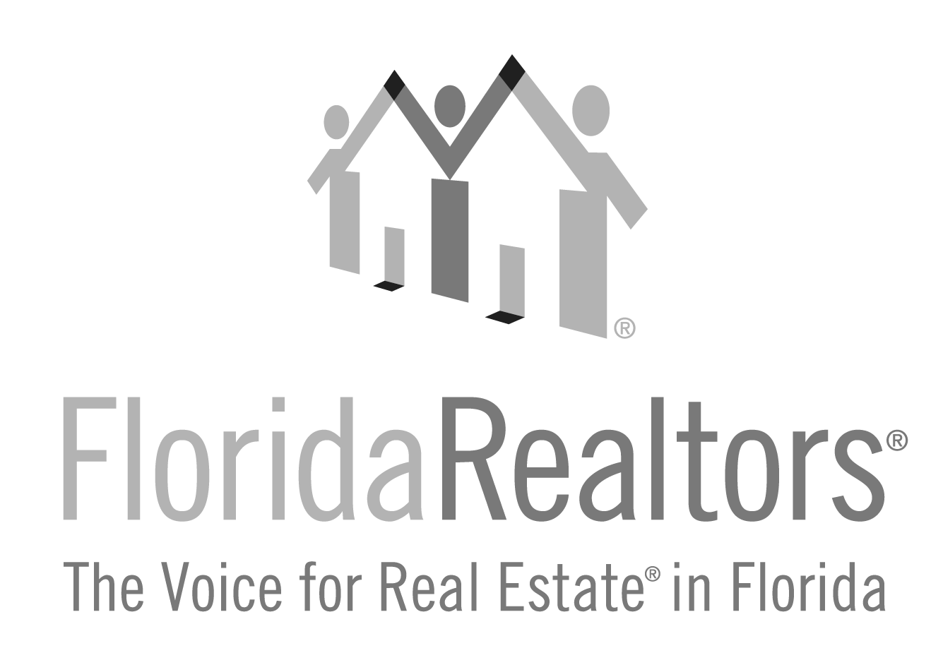

Humanitarian of the Year Award

2024 Entry Form

Honoring a Florida Realtors® member for their individual activity that will identify and recognize Realtors as compassionate, involved, sympathetic community members.

All applications must be received at Florida Realtors® by Friday, July 5, 2024. If you have any questions, please contact Gina Wittenhagen at (407) 438-1400, ext. 2343 or ginaw@floridarealtors.org

Full Name of Nominee:

Nominee’s Board/Association Affiliation:

Nominee’s Company & Title:

Nominee’s Complete Address:

Nominee’s Phone: Nominee’s E-mail:

Please identify the one organization that you feel has benefited most from your nominee’s volunteer work and activities:

Is this organization a 501(c)(3) nonprofit? Yes No

($5,000 Monetary award will only be issued to a 501(c)(3) nonprofit organization.)

EIN (Employer Identification Number):

Nature of the community work the nominee performed (brief description of the organization’s mission

and the candidate’s contribution):

Approximate number of hours involved overall Per week
Approximate number of hours involved in the real estate profession per week:

How many people were involved in implementing this project?
Was a committee formed to achieve the project’s goal? Yes No

Briefly describe the results of the nominee’s volunteer work, who benefited:

2024 Humanitarian Award Entry Form
Page 2

Is this the first year your nominee was involved with this project? Yes No
If not, how many years has he or she been involved?
Is this an ongoing project? Yes No
What inspired your nominee to become involved with this project?

Who may we contact at the nonprofit?

Name:

Charity/title:

Address:

Phone: E-mail:

Please list any other civic-minded activities in which your nominee has participated:

Local Board/Association President or Association Executive’s Signature

2024 Humanitarian Award Entry Form
Page 3

Please briefly describe the accomplishments and the extent of your nominee’s involvement in this project.
(No additional pages will be accepted RE: this project. Please use this form only at no less than 12-point type size.)

2024 Humanitarian Award Entry Form
Page 4

1.What contributions has this Associate Realtor made to the local board/association?

2. What contributions has this Associate Realtor made to the state association?

2024 Humanitarian Award Entry Form
Page 5

3. What contributions has this Associate Realtor made to the community?

4. What contributions has this Associate Realtor made to the national association?

