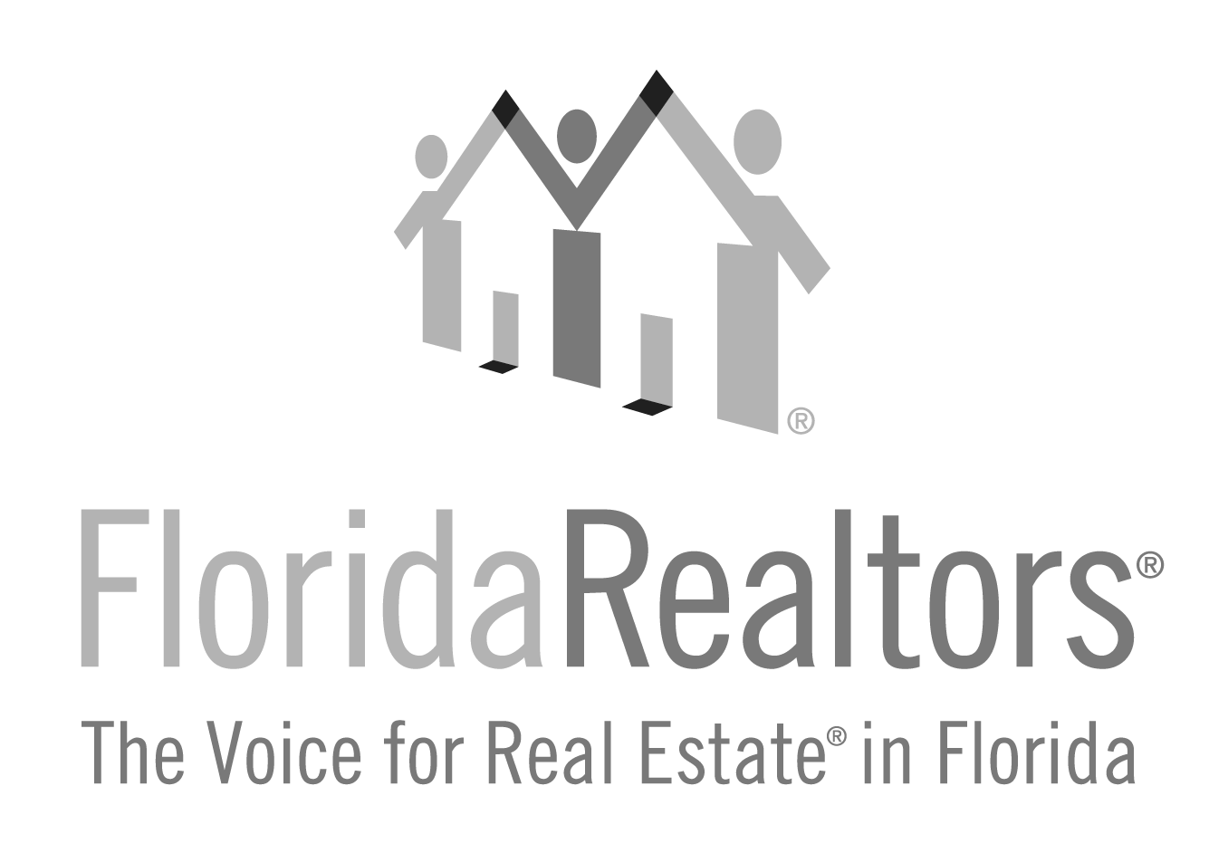

Commercial Realtor® Achievement

Honoring a Realtor®, based on lifetime contributions to the commercial activities of their local board/association, state association, national association and contributions to the community.

2024 Entry Form

All applications must be typed with no less than 12-point type size and must be received at Florida Realtors® by Friday, July 5, 2024. One letter of recommendation from the board/association is welcome but not required. If you have any questions, please contact Gina Wittenhagen at (407) 438-1400, ext. 2343 or ginaw@floridarealtors.org

Full Name of Nominee:

Nominee’s Board/Association Affiliation:

Nominee’s Company & Title:

Nominee’s Complete Address:

Please list qualifications/credentials/designations that qualify this applicant for this award:

_______________________________________________________________________________________Local Board/Association President or Association Executive’s Signature

Complete and return to:
Florida Realtors®
Attn: Gina Wittenhagen
7025 Augusta National Drive
Orlando, FL 32822-5017

Application must be received at Florida Realtors by Friday, July 5, 2024.
2024 Commercial Realtor® Achievement Award Entry Form
Page 2

1. What contributions has this Realtor made to the local board/association commercial activities?

2024 Commercial Realtor® Achievement Award Entry Form
Page 3

2. What contributions has this Realtor made to the state association commercial activities?

2024 Commercial Realtor® Achievement Award Entry Form
Page 4

3. What contributions has this Realtor made to the national association commercial activities?

2024 Commercial Realtor® Achievement Award Entry Form
Page 5

4. What contributions has this Realtor made to the community?

