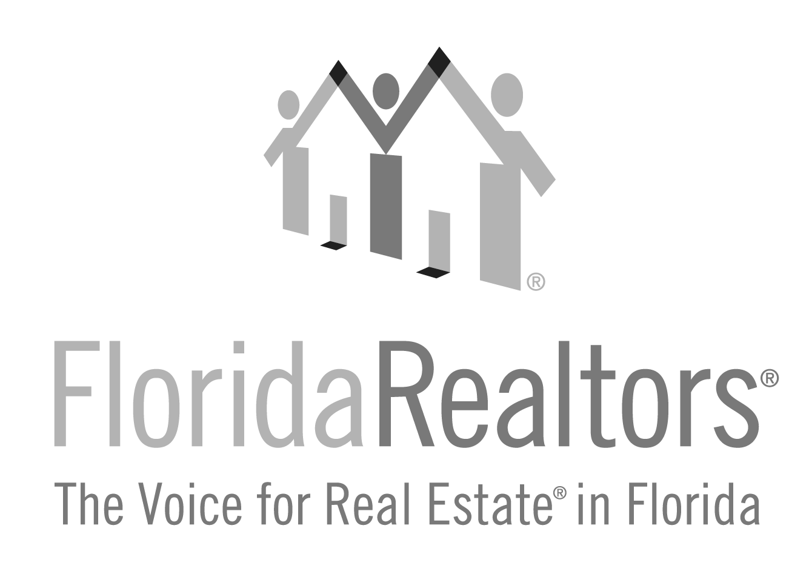
Associate Realtor® of the Year

Honoring an Associate Realtor® (serving their company primarily as a salesperson and is NOT a broker of record, manager or officer of a company) based on their lifetime contributions to their local board/association, state association, national association and community.

2024 Entry Form

All applications must be typed with no less than 12-point type size and must be received at Florida Realtors® by Friday, July 5, 2024. One letter of recommendation from the board/association is welcome but not required. If you have any questions, please contact Gina Wittenhagen at (407) 438-1400, ext. 2343 or ginaw@floridarealtors.org

Full Name of Nominee:

Nominee’s position in the company (Please verify and check at least one):

Broker of Record*
Manager*
Officer*
Salesperson

*Ineligible – Please see Realtor Achievement application.

Nominee’s Board/Association Affiliation:

Nominee’s Company & Title:

Nominee’s Complete Address:

_______________________________________________________________________________________Local Board/Association President or Association Executive’s Signature

Complete and return to:
Florida Realtors®
Attn: Gina Wittenhagen
7025 Augusta National Drive
Orlando, FL 32822-5017

Application must be received at Florida Realtors by Friday, July 5, 2024.
2024 Associate Realtor of the Year Award Entry Form
Page 2

1.What contributions has this Associate Realtor made to the local board/association?

2024 Associate Realtor of the Year Award Entry Form
Page 3

2. What contributions has this Associate Realtor made to the state association?

2024 Associate Realtor of the Year Award Entry Form
Page 4

3. What contributions has this Associate Realtor made to the community?

2024 Associate Realtor of the Year Award Entry Form
Page 5

4. What contributions has this Associate Realtor made to the national association?

